CPE 324-01: Advanced Logic Design Laboratory

Lab09

Alarm Clock Module

Submitted by: Esther Shore

Date of Experiment(s): April 18, 2024 and April 23, 2024

Report Deadline: April 25, 2024

1. Introduction

The purpose of this lab is to design and implement a digital alarm clock module using the DE2-115 Educational Trainer. The goal is to create a user-friendly interface that allows for the accurate display of time in 24-hour format, with the option to adjust both the current time and the alarm time independent of the clock. Additionally, the module will feature an audible alarm that can be reset by the user, with a maximum duration of 5 minutes if left unattended. This project will build upon previous assignments in CPE 324 and CPE 322, integrating previously made modules where applicable to enhance functionality.

1. Experiment Description

This experiment focuses on implementing a digital alarm clock module, meeting specific requirements outlined. The design ensures continuous time display in 24-hour format down to the seconds using the Clock_24_Hour_behavioral module created for CPE322 homework/simulation assignment. This module requires a 1 Hz clock signal in order to update the clock every second, so the module shown in Figure 4 was made to generate the desired signal from the built-in 50 MHz clock using a counter. We also had to be able to get the numbers from the clock module to be displayed on the hex display using a conversion module as shown in Figure 3.

User interaction is facilitated through the use of SW0 to enter set clock time mode and SW4 to enter set alarm time mode. Adjustments to the target time are made by selecting the units to increment using switches SW1, SW2, and SW3, which represent seconds, minutes, and hours respectively, and pressing KEY0 to increment. This logic is handled in the always statement in Figure 1 below.

| // KEY0: increment time based on switch settings  // SW0: set clock mode  // SW1: set seconds, SW2: set minutes, SW3: set hours  // SW4: set alarm mode  always @(posedge increment) begin  if (set_clock && !set_alarm) begin // set clock  if (set_sec && !set_min && !set_hr) begin // increment seconds  if (clock_out[7:0] == 8'h59)  clock_in[7:0] = 8'h00;  else if (clock_out[3:0] == 4'h9) begin  clock_in[7:4] = clock_out[7:4] + 4'h1;  clock_in[3:0] = 4'h0;  end else  clock_in = clock_out + 24'h000001;  end else if (!set_sec && set_min && !set_hr) begin // increment minutes  if (clock_out[15:8] == 8'h59)  clock_in[15:8] = 8'h00;  else if (clock_out[11:8] == 4'h9) begin  clock_in[15:12] = clock_out[15:12] + 4'h1;  clock_in[11:8] = 4'h0;  end else  clock_in = clock_out + 24'h000100;  end else if (!set_sec && !set_min && set_hr) begin // increment hours  if (clock_out[23:16] == 8'h23)  clock_in[23:16] = 8'h00;  else if (clock_out[19:16] == 4'h9) begin  clock_in[23:20] = clock_out[23:20] + 4'h1;  clock_in[19:16] = 4'h0;  end else  clock_in = clock_out + 24'h010000;  end else  clock_in = clock_out; // load stored time  end else if (!set_clock && set_alarm) begin // set alarm  if (set_sec && !set_min && !set_hr) begin // increment seconds  if (display_time[7:0] == 8'h59)  alarm_time[7:0] = 8'h00;  else if (display_time[3:0] == 4'h9) begin  alarm_time[7:4] = alarm_time[7:4] + 4'h1;  alarm_time[3:0] = 4'h0;  end else  alarm_time = display_time + 24'h000001;  end else if (!set_sec && set_min && !set_hr) begin // increment minutes  if (display_time[15:8] == 8'h59)  alarm_time[15:8] = 8'h00;  else if (display_time[11:8] == 4'h9) begin  alarm_time[15:12] = display_time[15:12] + 4'h1;  alarm_time[11:8] = 4'h0;  end else  alarm_time = display_time + 24'h000100;  end else if (!set_sec && !set_min && set_hr) begin // increment hours  if (display_time[23:16] == 8'h23)  alarm_time[23:16] = 8'h00;  else if (display_time[19:16] == 4'h9) begin  alarm_time[23:20] = display_time[23:20] + 4'h1;  alarm_time[19:16] = 4'h0;  end else  alarm_time = display_time + 24'h010000;  end else  alarm_time = clock_out; // set alarm to current time  end else begin  clock_in = clock_out; // store current time if not in set mode  end  end |
| --- |

Figure 1. KEY1 Increment Functionality Code Snippet

The set clock and set alarm modes in addition to the alarm sound and indicator are handled in another always statement as shown in Figure 2. When the user enters set alarm mode, the clock continues to operate normally, and only generates the audible alarm signal when not in a set time mode and the alarm is active as indicated by the LEDG8. The alarm signal duration is also limited to a maximum of 5 minutes if left unattended or can be canceled using the KEY2 reset button, which also makes the alarm time inactive even if it is not actively sounding the alarm. The alarm sound was generated using our pre-existing code created from lab6 part b Verilog module, reading audio data from a text file and altering the volume accordingly to either generate the audible signal or not. Through this experiment, the functionality and reliability of the digital alarm clock module will be thoroughly tested, ensuring accurate timekeeping and dependable alarm triggering, while also assessing user interaction and interface intuitiveness.

| always @(posedge CLK) begin  alarm_indicator = alarm_active; // LEDG8: alarm status  if (set_clock && !set_alarm) begin // set clock  set_time = 1'b1;  display_time = clock_out;  vol = 8'b00000000;  end else begin  set_time = 1'b0; // active clock  if (!set_clock && set_alarm) begin // set alarm  display_time = alarm_time;  alarm_active = 1'b1;  vol = 8'b00000000;  end else if (!set_clock && !set_alarm) begin // not setting clock or alarm  display_time = clock_out;  if (reset == 0) begin // KEY2: reset  vol = 8'b00000000;  alarm_active = 1'b0; // no sound and alarm inactive  end else if (clock_out == alarm_time && alarm_active) // trigger alarm  vol = 8'b10000000; // alarm sounds!  else if (vol == 8'b10000000 && (clock_out - alarm_time > 24'h000500)) begin // if over 5 minutes alarm sound  vol = 8'b00000000;  alarm_active = 1'b0; // no sound and alarm inactive  end  end  end  end |
| --- |

Figure 2. Set clock and handle alarm code snippet

| module hex_seven(n,hex);  input [3:0] n;  output reg [6:0] hex;  always @ (n)  case (n)  0 : hex <= 7'b1000000;  1 : hex <= 7'b1111001;  2 : hex <= 7'b0100100;  3 : hex <= 7'b0110000;  4 : hex <= 7'b0011001;  5 : hex <= 7'b0010010;  6 : hex <= 7'b0000010;  7 : hex <= 7'b1111000;  8 : hex <= 7'b0000000;  9 : hex <= 7'b0011000;  10 : hex <= 7'b0001000;  11 : hex <= 7'b0000011;  12 : hex <= 7'b1000110;  13 : hex <= 7'b0100001;  14 : hex <= 7'b0000110;  15 : hex <= 7'b0001110;  default : hex <= 7'bx;  endcase  endmodule |
| --- |

Figure 3. Convert number to hex display code

| module fiftyM_to_one_clk (  input clk,  output reg clk_out  );  reg [24:0] counter;  always @(posedge clk) begin  if (counter == 24999999) begin // 50 MHz / 2 = 25M for half period  counter <= 0;  clk_out <= ~clk_out; // toggle  end else begin  counter <= counter + 1;  end  end  endmodule |
| --- |

Figure 4. Convert 50 MHz clock to 1 Hz clock signal code

1. Demonstration

Through this experiment, we were able to demonstrate the full functionality of our alarm clock. To interface with our hardware devices, we connected the speaker to ground and pin D10 on the ECE breakout board and assigned the appropriate pins to our inputs and outputs for our top-level module. This was an essential step in order to ensure proper function and user interaction with our design.

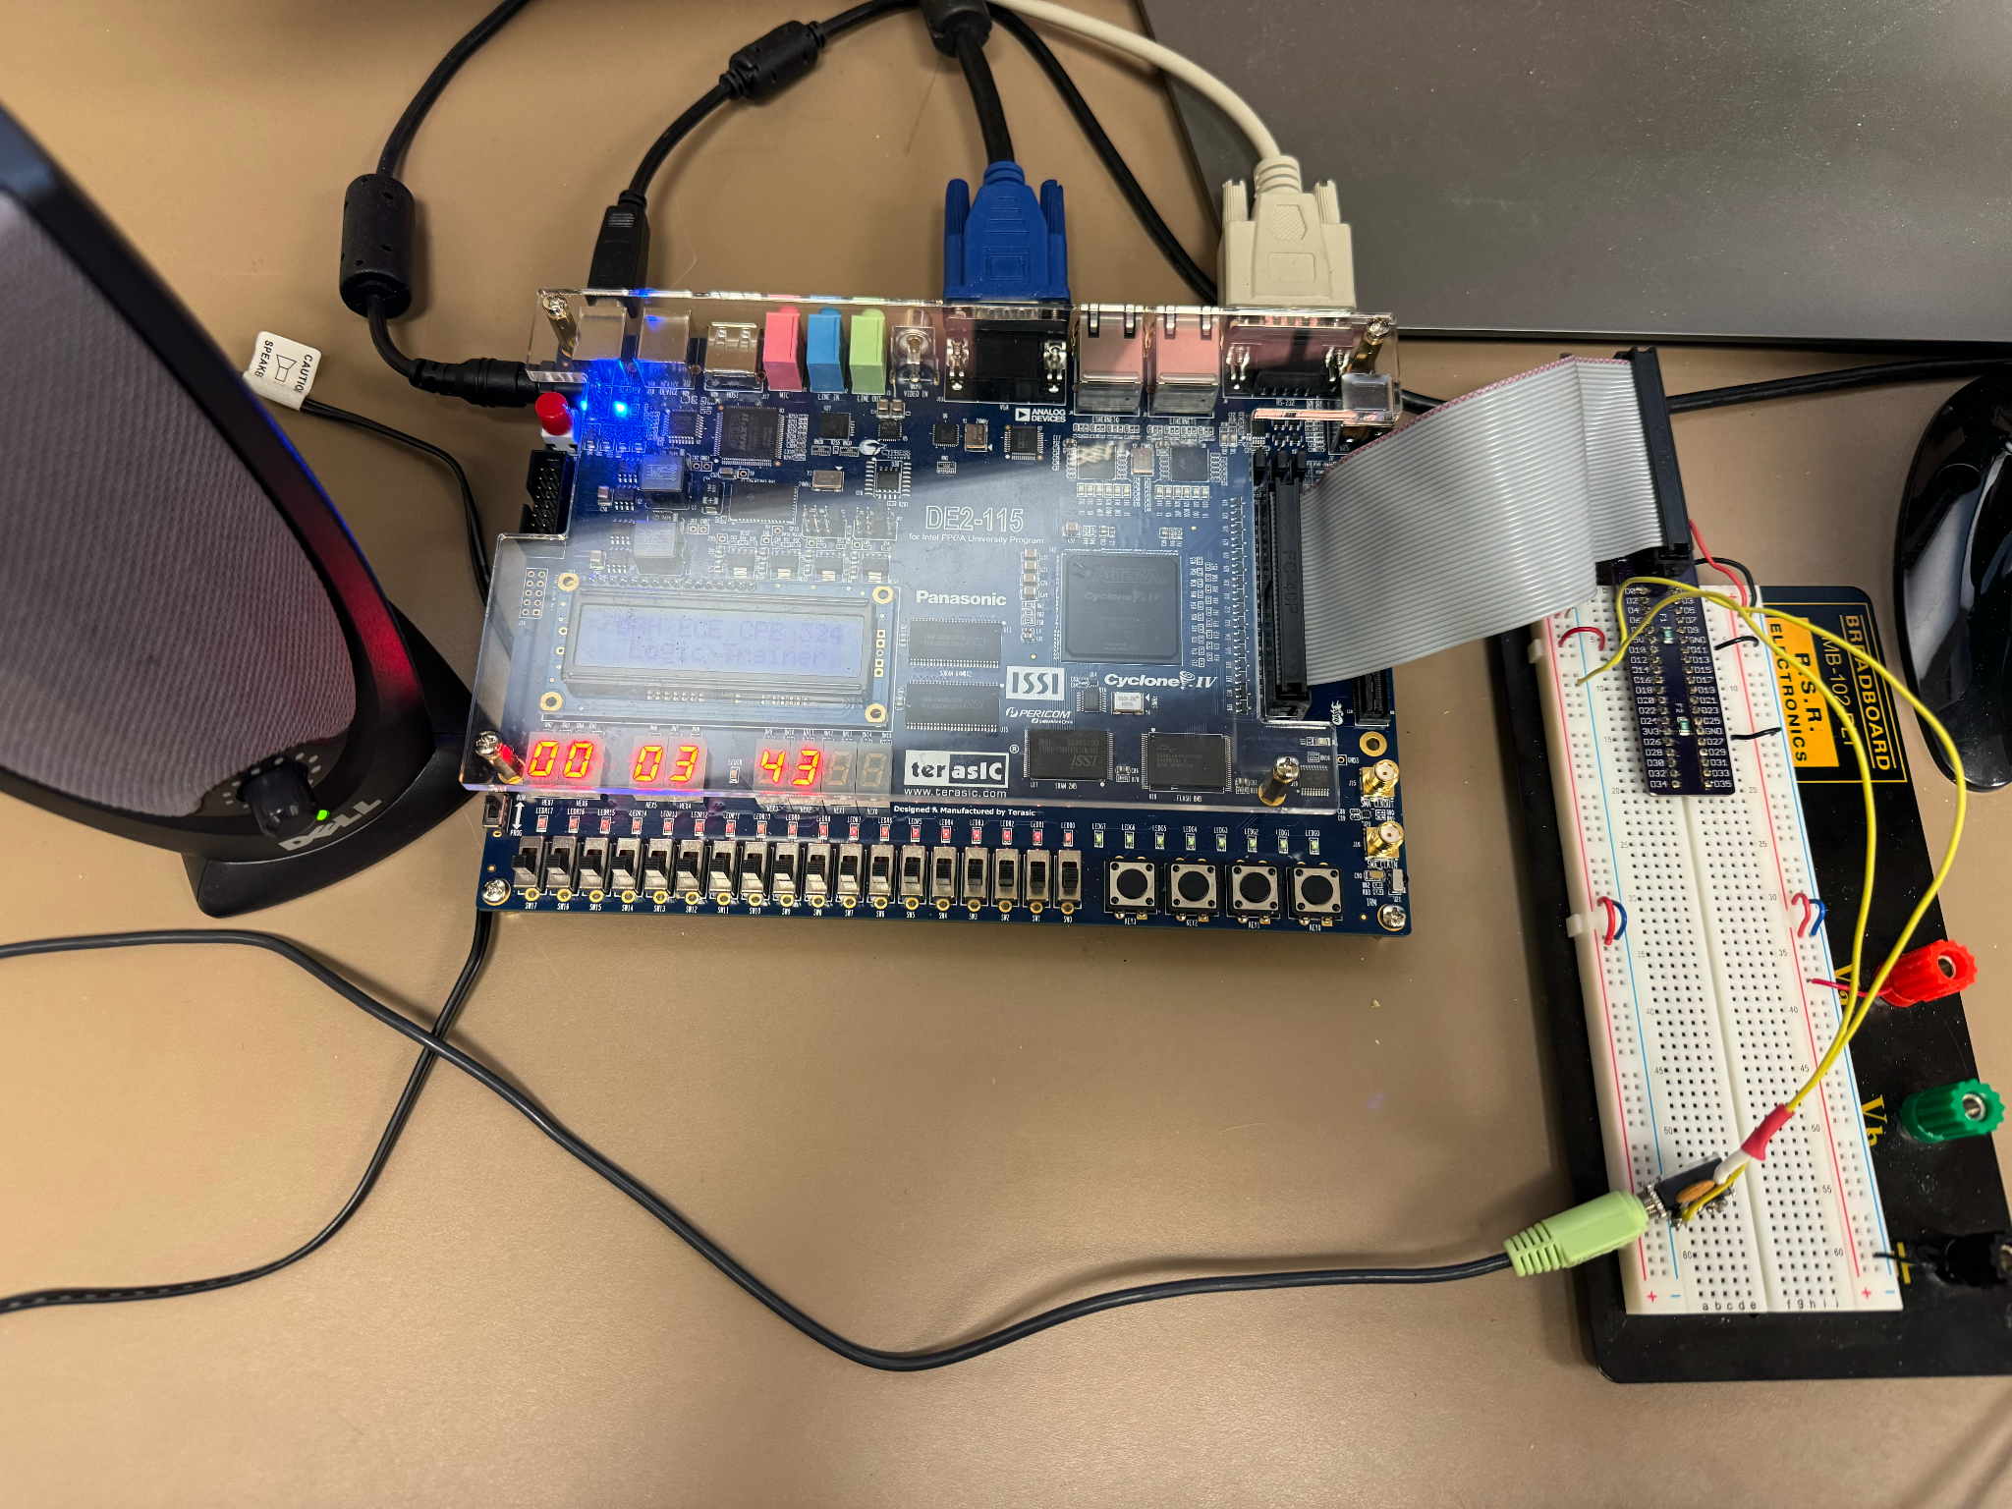

Figure 5. Real-time clock setup

We successfully displayed a 24 hour clock on the hex display and exhibited the ability to set the time using the increment key and the unit selection switches. This is shown in Figure 5 and 7. We also were able to set an alarm time independent of the running clock using our set alarm time switch and same increment controls. There is also an LED indicator of an active alarm time set and ability to reset with a key. This is shown in Figure 6.

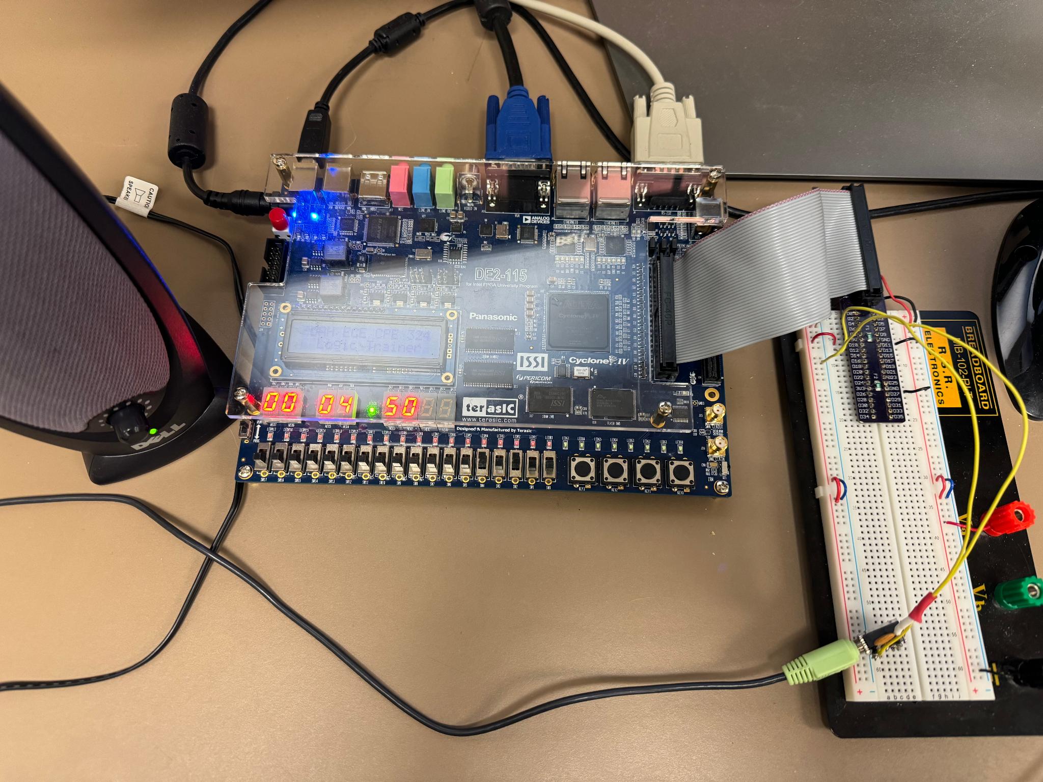

Figure 6. Set alarm time minutes

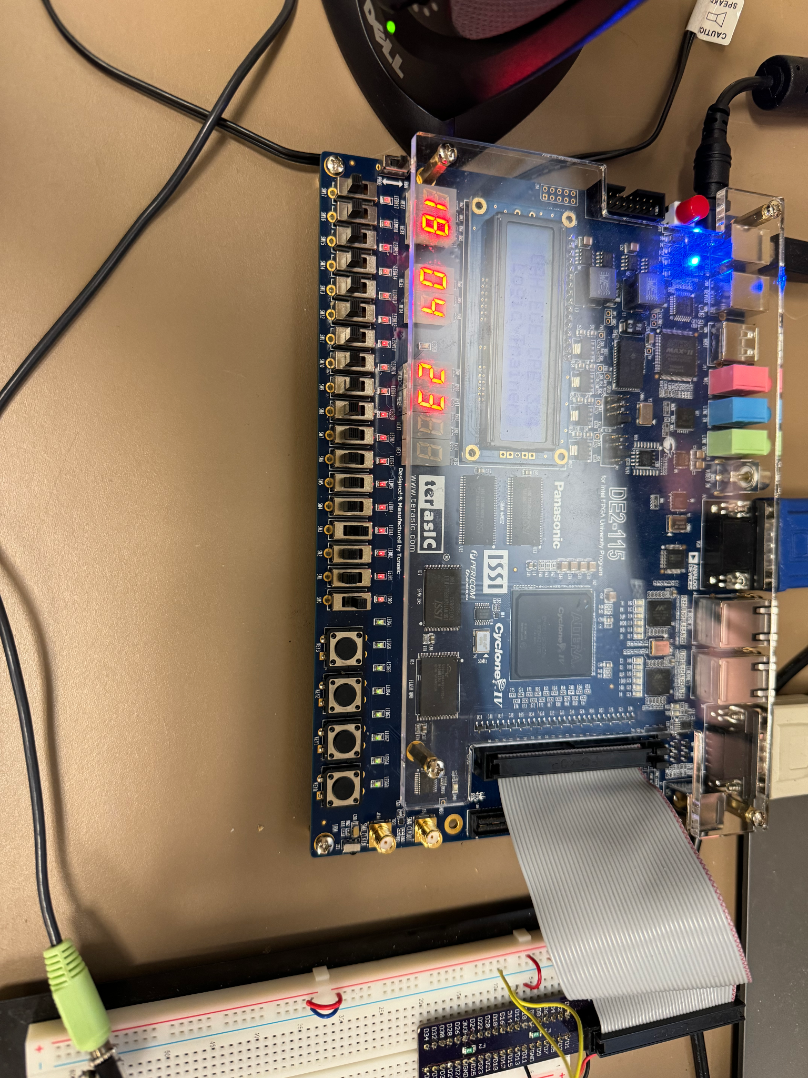

Figure 7. Set clock time hours

1. Experimental Results

The experimental results demonstrate the successful implementation of the digital alarm clock module on the DE2-115. The module accurately displays time in either 24-hour format and users can easily set both the clock time and alarm time using the provided controls, with ergonomically designed mechanisms facilitating intuitive adjustments.

The alarm functionality effectively generates audible signals, ensuring it is loud enough to wake the user. Furthermore, the alarm signal can be reset by pressing a button, with a maximum duration of 5 minutes if not reset. The LED indicator provides a clear indication of an active alarm. Overall, the implementation fulfills all requirements outlined in the lab assignment and demonstrates reliable performance on the DE2-115. The compilation summary is shown in Figure 8, exhibiting the resources used in this design.

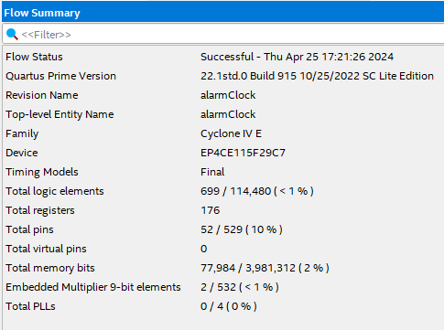

Figure 8. Compilation Results

1. Conclusion

In conclusion, the experiment successfully achieved its objectives by designing and implementing a digital alarm clock module on the DE2-115. The module accurately displayed time in 24-hour format, allowing users to easily set both the clock and alarm times through intuitive controls. The alarm function effectively generated audible signals and incorporated features such as a maximum alarm duration of 5 minutes and a reset option. Overall, the experiment demonstrated the functionality and reliability of the digital alarm clock module, meeting all specified requirements and showcasing dependable performance on the DE2-115 platform.

1. Appendix

alarmClock.v

| module alarmClock(  input CLK, set_clock, set_alarm, set_sec, set_min, set_hr, increment, reset,  output reg alarm_indicator,  output audio_out_bit,  output [6:0] HH, hh, MM, mm, SS, ss  );  // internal signals  reg [23:0] clock_in;  wire [23:0] clock_out;  reg [23:0] alarm_time;  reg [23:0] display_time;  wire reset_clock=1'b0;  wire clk_1hz;  reg set_time=1'b1;  reg alarm_active=1'b0;  reg alarm_en=1'b0;  reg [7:0] vol=8'b00000000;    initial begin  clock_in = 24'h000000;  alarm_time = 24'h000000;  end    // generate 1 Hz clk signal from 50 MHz CLK  fiftyM_to_one_clk one_hz_clk(.clk(CLK), .clk_out(clk_1hz));    // generate alarm sound from txt data file  audio alarm_sound(.clk(CLK), .vol(vol), .d_bit(audio_out_bit));    // KEY0: increment time based on switch settings  // SW0: set clock mode  // SW1: set seconds, SW2: set minutes, SW3: set hours  // SW4: set alarm mode  always @(posedge increment) begin  if (set_clock && !set_alarm) begin // set clock  if (set_sec && !set_min && !set_hr) begin // increment seconds  if (clock_out[7:0] == 8'h59)  clock_in[7:0] = 8'h00;  else if (clock_out[3:0] == 4'h9) begin  clock_in[7:4] = clock_out[7:4] + 4'h1;  clock_in[3:0] = 4'h0;  end else  clock_in = clock_out + 24'h000001;  end else if (!set_sec && set_min && !set_hr) begin // increment minutes  if (clock_out[15:8] == 8'h59)  clock_in[15:8] = 8'h00;  else if (clock_out[11:8] == 4'h9) begin  clock_in[15:12] = clock_out[15:12] + 4'h1;  clock_in[11:8] = 4'h0;  end else  clock_in = clock_out + 24'h000100;  end else if (!set_sec && !set_min && set_hr) begin // increment hours  if (clock_out[23:16] == 8'h23)  clock_in[23:16] = 8'h00;  else if (clock_out[19:16] == 4'h9) begin  clock_in[23:20] = clock_out[23:20] + 4'h1;  clock_in[19:16] = 4'h0;  end else  clock_in = clock_out + 24'h010000;  end else  clock_in = clock_out; // load stored time  end else if (!set_clock && set_alarm) begin // set alarm  if (set_sec && !set_min && !set_hr) begin // increment seconds  if (display_time[7:0] == 8'h59)  alarm_time[7:0] = 8'h00;  else if (display_time[3:0] == 4'h9) begin  alarm_time[7:4] = alarm_time[7:4] + 4'h1;  alarm_time[3:0] = 4'h0;  end else  alarm_time = display_time + 24'h000001;  end else if (!set_sec && set_min && !set_hr) begin // increment minutes  if (display_time[15:8] == 8'h59)  alarm_time[15:8] = 8'h00;  else if (display_time[11:8] == 4'h9) begin  alarm_time[15:12] = display_time[15:12] + 4'h1;  alarm_time[11:8] = 4'h0;  end else  alarm_time = display_time + 24'h000100;  end else if (!set_sec && !set_min && set_hr) begin // increment hours  if (display_time[23:16] == 8'h23)  alarm_time[23:16] = 8'h00;  else if (display_time[19:16] == 4'h9) begin  alarm_time[23:20] = display_time[23:20] + 4'h1;  alarm_time[19:16] = 4'h0;  end else  alarm_time = display_time + 24'h010000;  end else  alarm_time = clock_out; // set alarm to current time  end else begin  clock_in = clock_out; // store current time if not in set mode  end  end  always @(posedge CLK) begin  alarm_indicator = alarm_active; // LEDG8: alarm status  if (set_clock && !set_alarm) begin // set clock  set_time = 1'b1;  display_time = clock_out;  vol = 8'b00000000;  end else begin  set_time = 1'b0; // active clock  if (!set_clock && set_alarm) begin // set alarm  display_time = alarm_time;  alarm_active = 1'b1;  vol = 8'b00000000;  end else if (!set_clock && !set_alarm) begin // not setting clock or alarm  display_time = clock_out;  if (reset == 0) begin // KEY2: reset  vol = 8'b00000000;  alarm_active = 1'b0; // no sound and alarm inactive  end else if (clock_out == alarm_time && alarm_active) // trigger alarm  vol = 8'b10000000; // alarm sounds!  else if (vol == 8'b10000000 && (clock_out - alarm_time > 24'h000500)) begin // if over 5 minutes alarm sound  vol = 8'b00000000;  alarm_active = 1'b0; // no sound and alarm inactive  end  end  end  end    // 24 hour clock  Clock_24_Hour_behavioral clock_24(.clk(clk_1hz), .reset_time(reset_clock), .set_time(set_time), .inc_sec(inc_sec), .time_in(clock_in), .time_out(clock_out));    // convert digits to hex display  hex_seven Hr(.n(display_time[23:20]), .hex(HH)),  hr(.n(display_time[19:16]), .hex(hh)),  Mi(.n(display_time[15:12]), .hex(MM)),  mi(.n(display_time[11:8]), .hex(mm)),  Se(.n(display_time[7:4]), .hex(SS)),  se(.n(display_time[3:0]), .hex(ss));  endmodule  module hex_seven(n,hex);  input [3:0] n;  output reg [6:0] hex;  always @ (n)  case (n)  0 : hex <= 7'b1000000;  1 : hex <= 7'b1111001;  2 : hex <= 7'b0100100;  3 : hex <= 7'b0110000;  4 : hex <= 7'b0011001;  5 : hex <= 7'b0010010;  6 : hex <= 7'b0000010;  7 : hex <= 7'b1111000;  8 : hex <= 7'b0000000;  9 : hex <= 7'b0011000;  10 : hex <= 7'b0001000;  11 : hex <= 7'b0000011;  12 : hex <= 7'b1000110;  13 : hex <= 7'b0100001;  14 : hex <= 7'b0000110;  15 : hex <= 7'b0001110;  default : hex <= 7'bx;  endcase  endmodule  module fiftyM_to_one_clk (  input clk,  output reg clk_out  );  reg [24:0] counter;  always @(posedge clk) begin  if (counter == 24999999) begin // 50 MHz / 2 = 25M for half period  counter <= 0;  clk_out <= ~clk_out; // toggle  end else begin  counter <= counter + 1;  end  end  endmodule |
| --- |

Clock_24_Hour_behavioral.v

| module Clock_24_Hour_behavioral (  input clk,  input reset_time,  input set_time,  input inc_sec,  input [23:0] time_in,  output reg [23:0] time_out  );  // internal registers for counters and carry bits  reg [3:0] hr_tens, hr_ones, min_tens, min_ones, sec_tens, sec_ones;  reg c_out_sec, c_out_min, c_out_hr;  // counter and carry logic  always @(posedge clk or posedge reset_time or posedge set_time)  begin  if (reset_time) // async clear  begin  hr_tens <= 4'd0;  hr_ones <= 4'd0;  min_tens <= 4'd0;  min_ones <= 4'd0;  sec_tens <= 4'd0;  sec_ones <= 4'd0;  c_out_sec <= 1'b0;  c_out_min <= 1'b0;  c_out_hr <= 1'b0;  end  else if (set_time) // async load  begin  hr_tens <= time_in[23:20];  hr_ones <= time_in[19:16];  min_tens <= time_in[15:12];  min_ones <= time_in[11:8];  sec_tens <= time_in[7:4];  sec_ones <= time_in[3:0];  c_out_sec <= 1'b0;  c_out_min <= 1'b0;  c_out_hr <= 1'b0;  end  else // synchronous counter  begin  // seconds  if (sec_ones == 4'd9 && sec_tens == 4'd5) // threshold value  begin  sec_ones <= 4'd0;  sec_tens <= 4'd0;  c_out_sec <= 1'b1; // carry to minutes  // minutes  if (min_ones == 4'd9 && min_tens == 4'd5)  begin  min_ones <= 4'd0;  min_tens <= 4'd0;  c_out_min <= 1'b1;  // hours  if (hr_ones == 4'd3 && hr_tens == 4'd2)  begin  hr_ones <= 4'd0;  hr_tens <= 4'd0;  end  else if (hr_ones == 4'd9)  begin  hr_ones <= 4'd0;  hr_tens <= hr_tens + 1;  end  else hr_ones <= hr_ones + 1;  c_out_min <= 1'b0; // reset minutes carry  end  else if (min_ones == 4'd9)  begin  min_ones <= 4'd0;  min_tens <= min_tens + 1;  end  else min_ones <= min_ones + 1;  c_out_sec <= 1'b0; // reset seconds carry    end  else if (sec_ones == 4'd9) // carry to tens place  begin  sec_ones <= 4'd0;  sec_tens <= sec_tens + 1;  end  else sec_ones <= sec_ones + 1;  end  end    // output updated time  always @(*)  begin  time_out = {hr_tens, hr_ones, min_tens, min_ones, sec_tens, sec_ones};  end  endmodule |
| --- |

audio.v

| module audio (input clk, input [7:0] vol, output reg d_bit);  reg signed [1:-14] wave_out;  reg signed [1:-14] audio[0:4873];    initial  begin:wave_table_init  $readmemh("audio_16_signed.txt", audio);    // 16 bit signed fixed point encoding of 1.0 assuming a  //1 bit mantisa and a 14 bit fraction  `define ONE_16 {1'b0,1'b1,14'b0}  end    always @(posedge clk)  begin:Audio_Out  reg [12:0] count;  reg [12:0] base_count;  reg [16:0] index;  base_count = 13'd6250; // 50MHz/8kHz  if (count)  begin  count = count - 13'd1;  end  else  begin  if (index >= 17'd4873) index = 17'd0;  else index = index + 17'd1;  wave_out = audio[index]; // {audio[index], 8'd0} for 8-bit  count = base_count;  end  end    always @ (posedge clk)  begin:DtoA_convert  // declaring local variable to  // named section DtoA_convert  reg signed [3:-28] ge; // error term    pdm(d_bit,wave_out,{2'b00,vol,6'd0},ge);  end    // Pulse Density Modulation Task  task pdm(output d_out, input signed [1:-14] x, scale,  inout signed [3:-28] ge);    // 32-bit fixed point encoding of 1.0 assuming a  // signed 3 bit mantisa and a 28 bit fraction  `define ONE_32 {1'b0,3'b001,28'b0}  // 32 bit fixed-point holder of x * scale data  reg signed [3:-28] x_total;  begin  x_total = x*scale; // signal multiplication  if (x_total >= ge)  begin  d_out = 1;  ge = ge + (`ONE_32 - x_total);  end  else  begin  d_out = 0;  ge = ge - (`ONE_32 + x_total);  end  end  endtask    endmodule |
| --- |